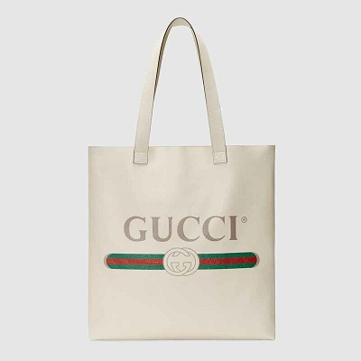

Gucci Print leather tote

PRODUCT DETAILS

**Crafted from soft textured white leather, the tote bag has a supple, unstructured shape.**

**Printed with the Gucci logo, inspired by vintage prints from the eighties, the unlined**

**carryall has two double handles with an elongated drop so it can be worn on the**

**shoulder.**

**Gucci Print • Double handles with 11" drop • No closure • Made in Italy**